Exercise 1: Implementing the Singleton Pattern
using System;

namespace SingletonPatternExample
{
public class Logger
{
private static Logger instance;
private static readonly object lockObj = new object();
private Logger()
{
Console.WriteLine("Logger instance created.");
}
public static Logger GetInstance()
{
if (instance == null)
{
lock (lockObj)
{
if (instance == null)
{
instance = new Logger();
}
}
}
return instance;
}
public void Log(string message)
{
Console.WriteLine($"[LOG]: {message}");
}
}
}

using System;

namespace SingletonPatternExample
{
class Program
{
static void Main(string[] args)
{
Logger logger1 = Logger.GetInstance();
Logger logger2 = Logger.GetInstance();
logger1.Log("First message");
logger2.Log("Second message");
if (logger1 == logger2)
{
Console.WriteLine("Both loggers are the same instance.");
}
else
{
Console.WriteLine("Different logger instances.");
}
}
}
}

//output :

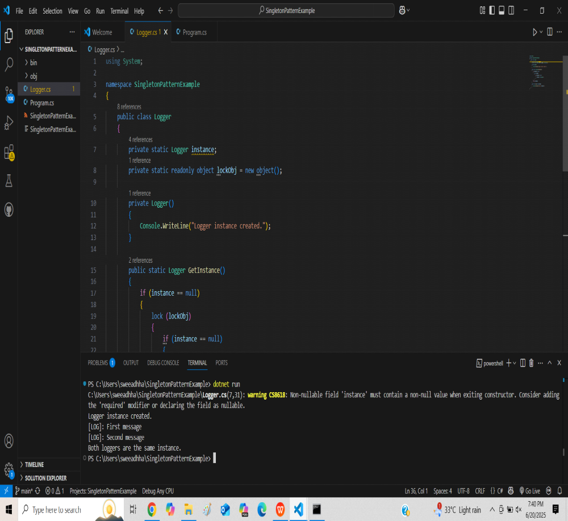

Exercise 2: Implementing the Factory Method Pattern
//code:
namespace FactoryMethodPatternExample
{
public interface IDocument
{
void Open();
}
}

namespace FactoryMethodPatternExample
{
public class WordDocument : IDocument
{
public void Open()
{
Console.WriteLine("Opening a Word document...");
}
}
}
namespace FactoryMethodPatternExample
{
public class PdfDocument : IDocument
{
public void Open()
{
Console.WriteLine("Opening a PDF document...");
}
}
}
namespace FactoryMethodPatternExample
{
public class ExcelDocument : IDocument
{
public void Open()
{
Console.WriteLine("Opening an Excel document...");
}
}
}

namespace FactoryMethodPatternExample
{
public abstract class DocumentFactory
{
public abstract IDocument CreateDocument();
}
}

namespace FactoryMethodPatternExample
{
public class WordFactory : DocumentFactory
{
public override IDocument CreateDocument()
{
return new WordDocument();
}
}
}

namespace FactoryMethodPatternExample
{
public class PdfFactory : DocumentFactory
{
public override IDocument CreateDocument()
{
return new PdfDocument();
}
}
}

namespace FactoryMethodPatternExample
{
public class ExcelFactory : DocumentFactory
{
public override IDocument CreateDocument()
{
return new ExcelDocument();
}
}
}

using System;

namespace FactoryMethodPatternExample
{
class Program
{
static void Main(string[] args)
{
DocumentFactory wordFactory = new WordFactory();
IDocument wordDoc = wordFactory.CreateDocument();
wordDoc.Open();
DocumentFactory pdfFactory = new PdfFactory();
IDocument pdfDoc = pdfFactory.CreateDocument();
pdfDoc.Open();
DocumentFactory excelFactory = new ExcelFactory();
IDocument excelDoc = excelFactory.CreateDocument();
excelDoc.Open();
}
}
}
//output :
